A000-Asia-***Haniwa*** terracotta clay ritual figurine, Kofun Period, Yamato Kingdom, 250 to 538 CE

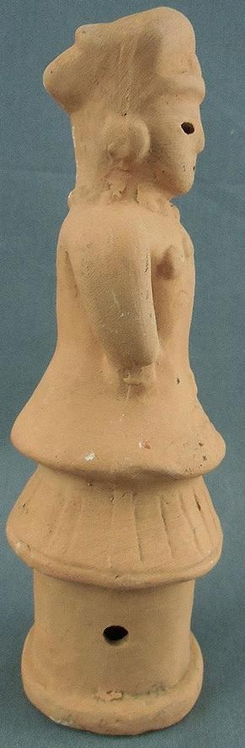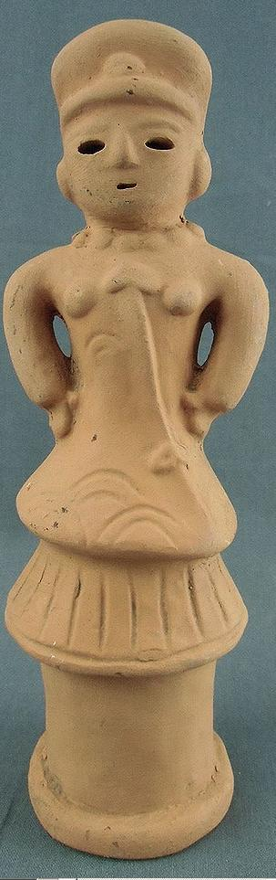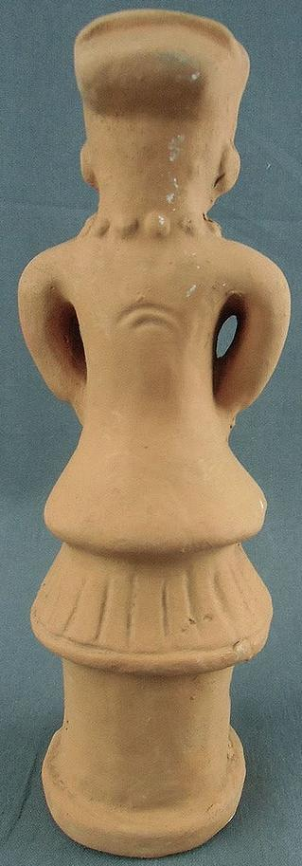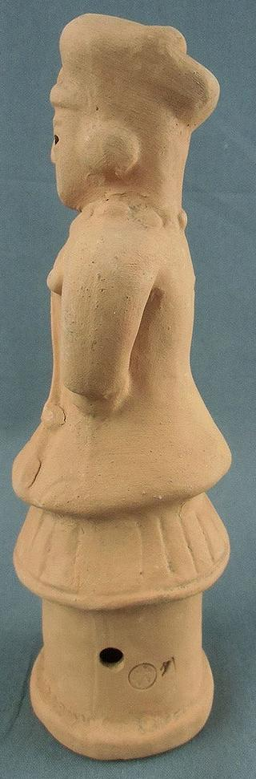

Fig. 1. Japanese ***Haniwa*** of Kofun entombed official, terracotta clay ritual figurine, Kofun Period, Yamato Kingdom, ca. 250 to 538 AD/CE

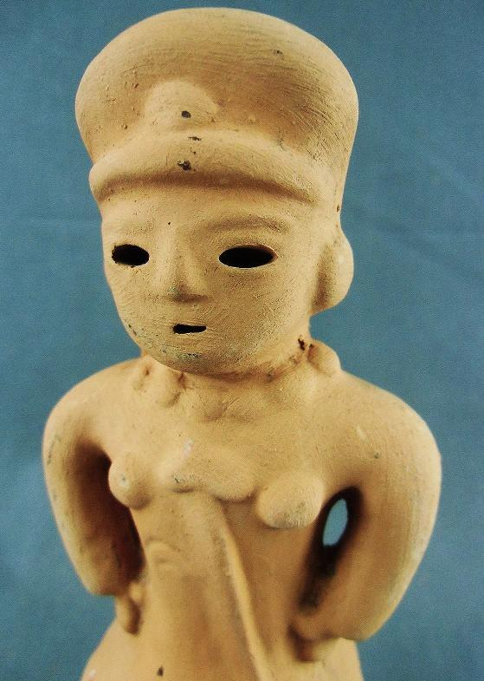 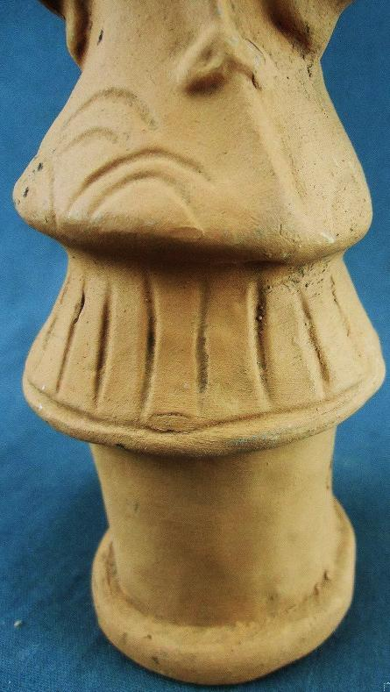

Fig. 2, a-b. Detail.

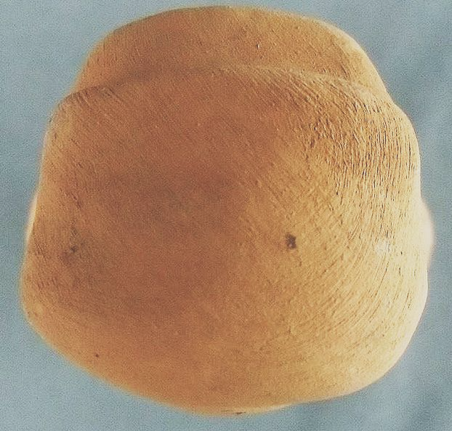 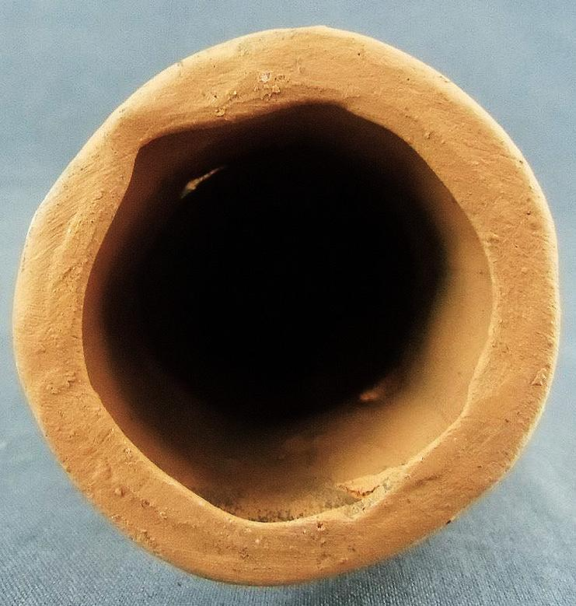

Fig. 3, a-b, detail of military peaked cap and hollow interior, respectively.

Formal Label: Japanese ***Haniwa*** terracotta ritual figurine of an official, Kofun Period, Yamato Kingdom, ca. 250 to 538 AD/CE

Accession Number: NB159.J3.A1

Date or Time Horizon: 3rd century AD/CE- mid-6th century AD/CE; replica, 1900-1940.

Geographical Area: Kyushu to Nagata Prefecture, Honshu

Cultural Affiliation: Kofun Period, Yamato Kingdom, ca. 250 to 538 AD/CE

Media: terracotta

Dimensions:

Weight:

Provenance: Daniel Dittmar, Ama-Gun, Japan.

This Japanese ***Haniwa*** terracotta ritual male figurine of an official, Kofun Period, Yamato Kingdom, ca. 250 to 538 AD/CE, was entombed in a ***Kofun***. It wears the distinctive uniform of the Yamato Kingdom officer – military peaked cap with visor and medallion, a necklace of medals, an official military jacket with epaulettes (on the front in this case) signifying rank, from which depends an "aiguillette" (French, *small needle*), an ornamental braided cord fastened from one of the breast medals on the jacket to a fibula-type mechanical fastener on the lower jacket (see Fig. 2, a-b). The lower torso is covered by a kilt-type, pleated skirt, encircled by an edging of piping. The details do not indicate that this is covered in chain mail. The entire structure is situated on a pedestal that serves as a schematic legging. The interior of the cylinder is hollow to allow the spirit to enter (see Fig. 3, b).

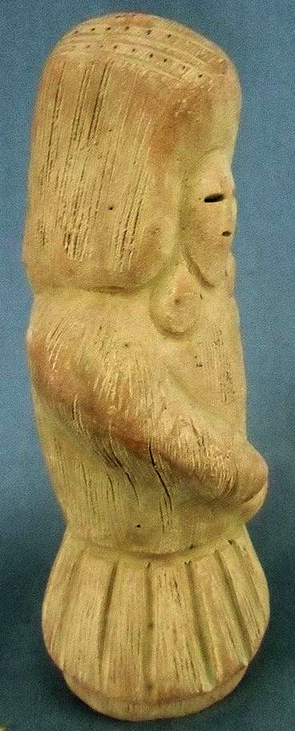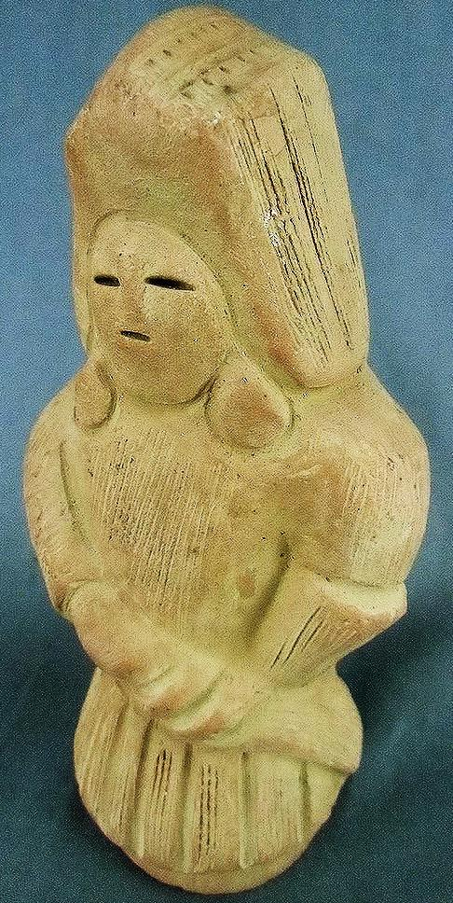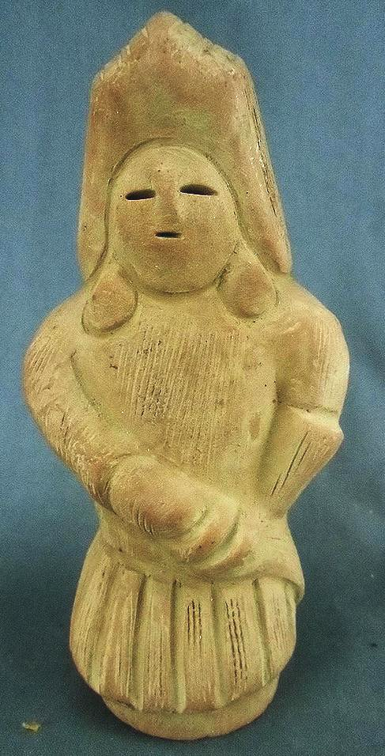

Fig. 4, a-c. Japanese ***Haniwa*** terracotta ritual figurine of an official, Kofun Period, Yamato Kingdom, ca. 250 to 538 AD/CE

This Japanese ***Haniwa*** terracotta ritual figurine of a male warrior of the Kofun Period, Yamato Kingdom, ca. 250 to 538 AD/CE, was entombed in a ***Kofun*** as an apotropaic figure to protect and guard its entombed Yamato Kingdom official. He wears the distinctive uniform of a warrior of the Yamato Kingdom: a helmet with chain mail on its sides and an angular flat mail plaited top (see Fig. 4 h) to give the infantry warrior greater height and protection and hence advantage in hand-to-hand combat, a military jacket perhaps with inter-locked, circular chain mail on the right sleeve (the slashing arm side). The right hand is protected by a gauntlet and is holding a short, wide-blade sword situated in a sheath. The left hand is also protected by a gauntlet and is stabilizing the sword in it sheath for quick release. The lower torso is covered by a kilt-type, pleated skirt, which is, perhaps, constructed of chain mail (see Fig 4, i). The interior of the cylinder is hollow to allow the spirit to enter (see Fig. 4, g).

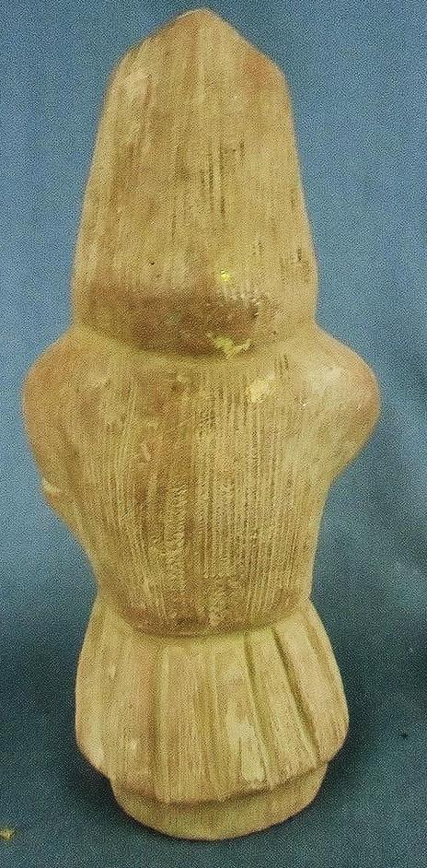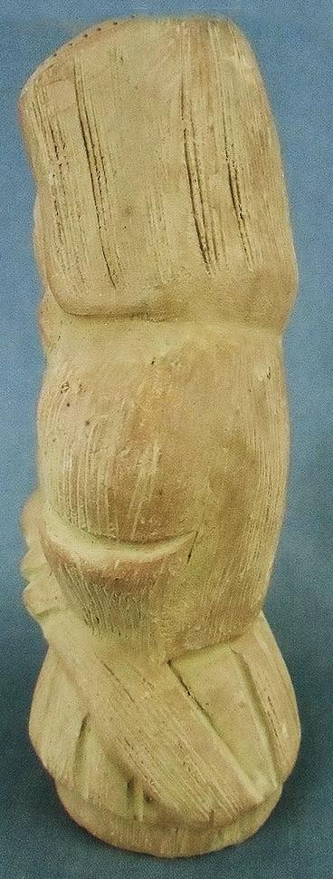

Fig. 4, d-f. Japanese ***Haniwa*** terracotta ritual figurine of an official, Kofun Period, Yamato Kingdom, ca. 250 to 538 AD/CE. Additional views.

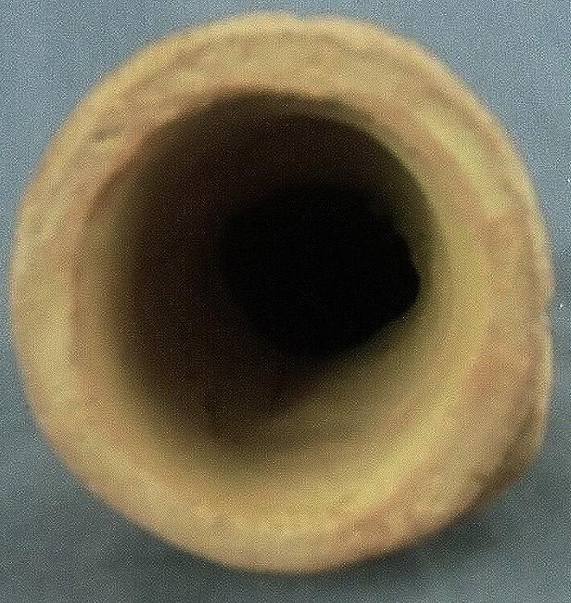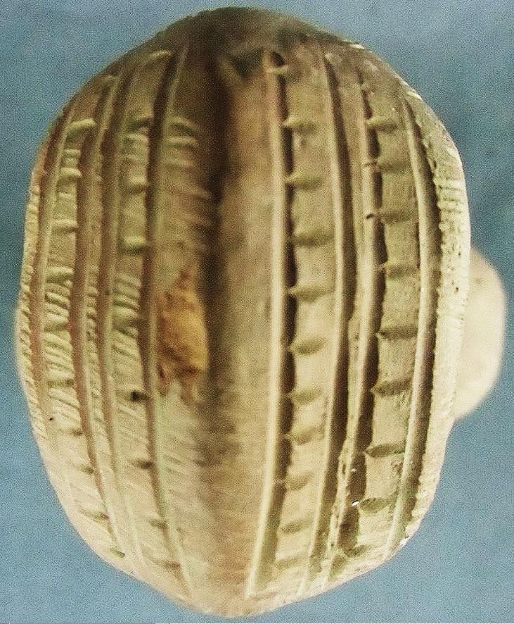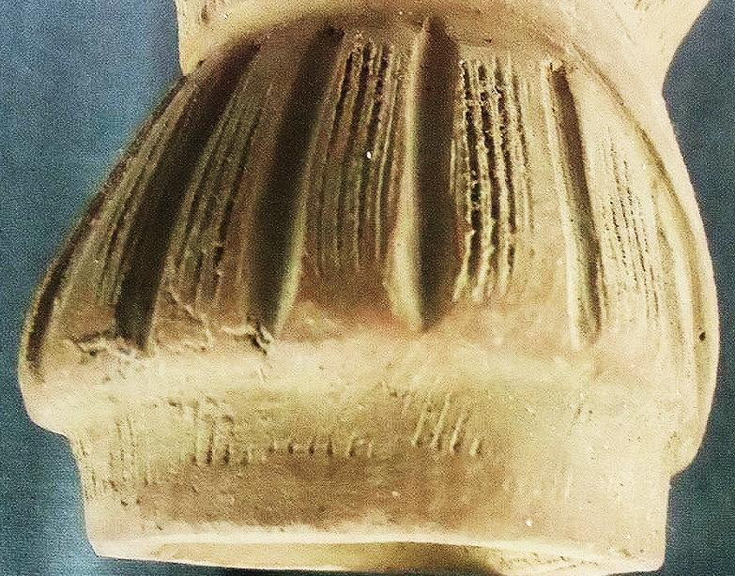

Fig. 4, g-i. Japanese ***Haniwa*** air-dried terracotta ritual figurine of an official, Kofun Period, Yamato Kingdom, ca. 250 to 538 AD/CE: details, hollow cylinder, helmet piece showing plaited mail, pleated kilt showing vertical chain mail, respectively.

Formal Label: Japanese ***Haniwa*** air-dried terracotta ritual figurine of a warrior, Kofun Period, Yamato Kingdom, ca. 250 to 538 AD/CE.

Accession Number: NB159.J3.A2

Date or Time Horizon: 3rd century AD/CE- mid-6th century AD/CE; replica, 1900-1940.

Geographical Area: Kyushu to Nagata Prefecture, Honshu

Cultural Affiliation: Kofun Period, Yamato Kingdom, ca. 250 to 538 AD/CE

Media: terracotta

Dimensions: H 7 in

Weight:

Provenance: Daniel Dittmar, Ama-Gun, Japan.

# Background of the Haniw

In Japan ***Haniwa*** are figurines molded on a cylindrical form of coiled terracotta, then shaped and air-dried. They date to the Kofun Period, Yamato Kingdom, ca. 250 to 538 AD/CE. At least 15,000 known examples were interred as Shinto religious funerary objects in ***Kofun*** tumuli (burial mounds) of which there are some 100,000 known throughout the Japanese archipelago, extending from the Nigata Prefecture on the main island of Honshû to the southern part of the island of Kyûshû and its minuscule offshore island of Yakushima. Since ***Kofun*** were burial mounds for members of the ruling élite, together with their ***Haniwa*** they engendered powerful political significance as monumental structures and figural images respectively.

The origin of ***Haniwa*** date to the latter part of the Yayoi period’s Kibi Kingdom of the early third century AD/CE, when western Kyushu acted as a cultural bridge between Japan and Korea. During this time special earthenware figurines and bowls began to appear on top of the tombs of leaders. The early sculptures exceeded 1 meter (3 feet) in length. They consisted of a cylindrical portion, which represented the torso, and a skirt-shaped portion at the base. Many times a special insignia or pattern would be displayed on the torso. Sometimes an *obi* would be placed around the torso portion of the sculpture. These sculptures are thought to have been used as part of a funeral ritual.

During the latter part of the 3rd century AD/CE, these sculptures started to appear on top of the imperial grave mounds in the Kansai or Kinki region where Nara, an important cultural city was located. During this time more elaborate ***Haniwa*** would appear along with earthenware bowls. It is believed that the movement of these sculptures and ***Haniwa*** from the Kibi region to the Kansai or Kinki region is indicative of an increase in the importance.

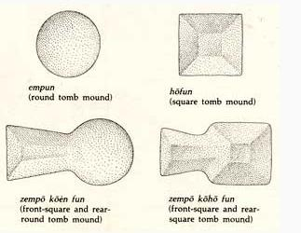

Fig. 5. Four Kofun structures.after http://www.jref.com/images/articles/kofun-types.jpg

During the earlier part of the ***Kofun*** period (later 3rd century AD/CE) the only earthenware ***Haniwa*** were of the cylindrical variety; however, towards the early 4th century AD/CE, shield and other tool-shaped ***Haniwa*** started to appear. Additionally, during the middle ***Kofun*** period (mid-5th century AD/CE) shrine maidens, horses, dogs ***Kofun*** ceremonial burial mounds declined in the mid-6th century AD/CE, ***Haniwa*** became rarer in the Kinai (or Kinki) region; however, the ***Haniwa*** were still made in abundance in the Kantō region.

A unique cultural tradition formed around the ***Kofun*** and their ***Haniwa***, for the scale, forms, and design of the ***Kofun*** expressed both the sociopolitical structure and regional interrelationships of a hierarchical political order. ***Kofun*** were built in a variety of sizes, forms, and styles, from relatively simple round or square mounds *(empun* or *hôfun*) to the more elaborate keyhole-shaped tombs, either rounded at the back (*zempô kôen fun*; “rounded keyhole-shaped ***Kofun***”) or squared off (zempô kôhô fun). Yet throughout the ***Kofun*** Period, it was the rounded keyhole-shaped ***Kofun*** that represented the highest class of tumuli and were built to the grandest scale.

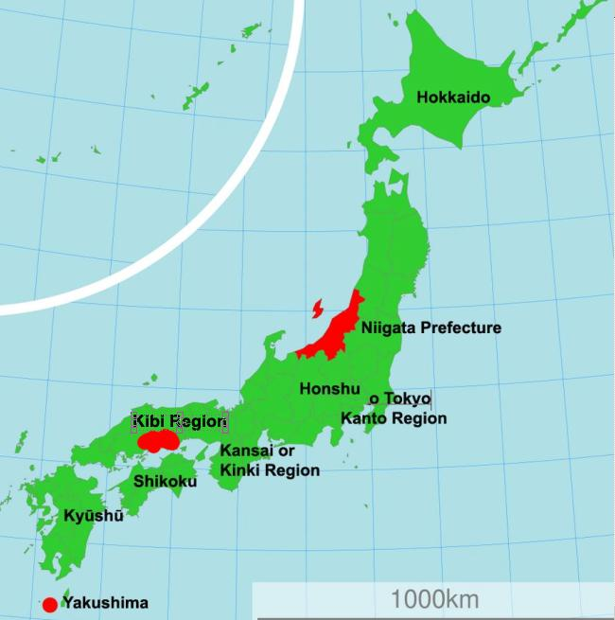

Fig. 6 . Places mention in the text.

Originally, the cylindrically shaped ***Haniwa*** were set on top of the ***Kofun*** burial mounds, where the soul of the deceased would reside establishing a role in Shinto funeral rituals. Some ***Haniwa*** are equipped with weapons and armor, and these are also thought to be the containers for souls of spiritual warriors who would protect the deceased from intruders. The cylindrical shape of these figurines was thought to encompass an indwelling spirit.

***Haniwa*** ceramicists followed the *wazumi* water-based coiled clay technique to shape the figure, clay coil by coil and then they were smoothed using a wooden paddle. The ***Haniwa*** were then dried into a coarse and absorbent material that stood the test of time. The protruding parts of the figures were made separately and then attached, while a few things were carved into them. A wooden paddle smoothed them out. Earth terraces were arranged to place them with a cylindrical base into the ground, where the earth would hold them in place. Because these ***Haniwa*** display contemporary clothing, hairstyles, weapons, farming tools, and architecture, these sculptures are important as a historical archive of the ***Kofun*** Period.

|  |  |
| --- | --- |
| ORDER DATENov 28, 2016 | ORDER TOTAL  US $41.94  + US $27.00  shipping  **Order BD211 Japanese Statue Dogu Haniwa Ancient Pottery Clay Brown Vintage Okimono,BD190 Japanese Dogu Haniwa Statue Clay Figure Vtg Buddhist H:7in Okimono** [View order details - ORDER DATE Nov 28, 2016](http://payments.ebay.com/ws/eBayISAPI.dll?ViewPaymentStatus&transId=1956708213015&itemid=252638883509&_trksid=p2057872.m2749.l2673)[Contact seller](http://contact.ebay.com/ws/eBayISAPI.dll?ShowSellerFAQ&requested=dimastyle&iid=252638883509&redirect=0&_trksid=p2057872.m2749.l2652) - ORDER DATE Nov 28, 2016  [More actions - ORDER DATE Nov 28, 2016](http://www.ebay.com/myb/PurchaseHistory) |

2 items sold by [dimastyle](http://www.ebay.com/usr/dimastyle?_trksid=p2057872.m2749.l2754)

|  |  |  |
| --- | --- | --- |
| [BD211 Japanese Statue Dogu ***Haniwa*** Ancient Pottery Clay Brown Vintage Okimono](http://www.ebay.com/itm/252638883509?_trksid=p2057872.m2749.l2649&ssPageName=STRK%3AMEBIDX%3AIT)  ( 252638883509 )  Estimated delivery Tue, Dec 06 - Tue, Dec 13  [Add note](javascript:;) | ITEM PRICE:  US $20.97 | **Item BD211 Japanese Statue Dogu Haniwa Ancient Pottery Clay Brown Vintage Okimono Orders 252638883509-0-1956708213015**[Leave feedback](http://feedback.ebay.com/ws/eBayISAPI.dll?LeaveFeedbackShow&useridto=dimastyle&transactID=1956708213015&item=252638883509&_trksid=p2057872.m2749.l2665)[View similar items](http://www.ebay.com/sch/sis.html?_nkw=BD211+Japanese+Statue+Dogu+Haniwa+Ancient+Pottery+Clay+Brown+Vintage+Okimono&_id=252638883509&&_trksid=p2057872.m2749.l2658)  [More actions](http://www.ebay.com/myb/PurchaseHistory) |

|  |  |
| --- | --- |
| [BD190 Japanese Dogu ***Haniwa*** Statue Clay Figure Vtg Buddhist H:7in Okimono](http://www.ebay.com/itm/252638897779?_trksid=p2057872.m2749.l2649&ssPageName=STRK%3AMEBIDX%3AIT)  ( 252638897779 )  Estimated delivery Tue, Dec 06 - Tue, Dec 13  [Add note](javascript:;) | ITEM PRICE:  US $20.97 |